1. The September 2012 data is downloaded as mentioned.
2. RDS database service

1. Here I haver highlighted the sed command and before and after wc command count, also after running the head command my file Sai-sep2012.csv shows the header is removed.

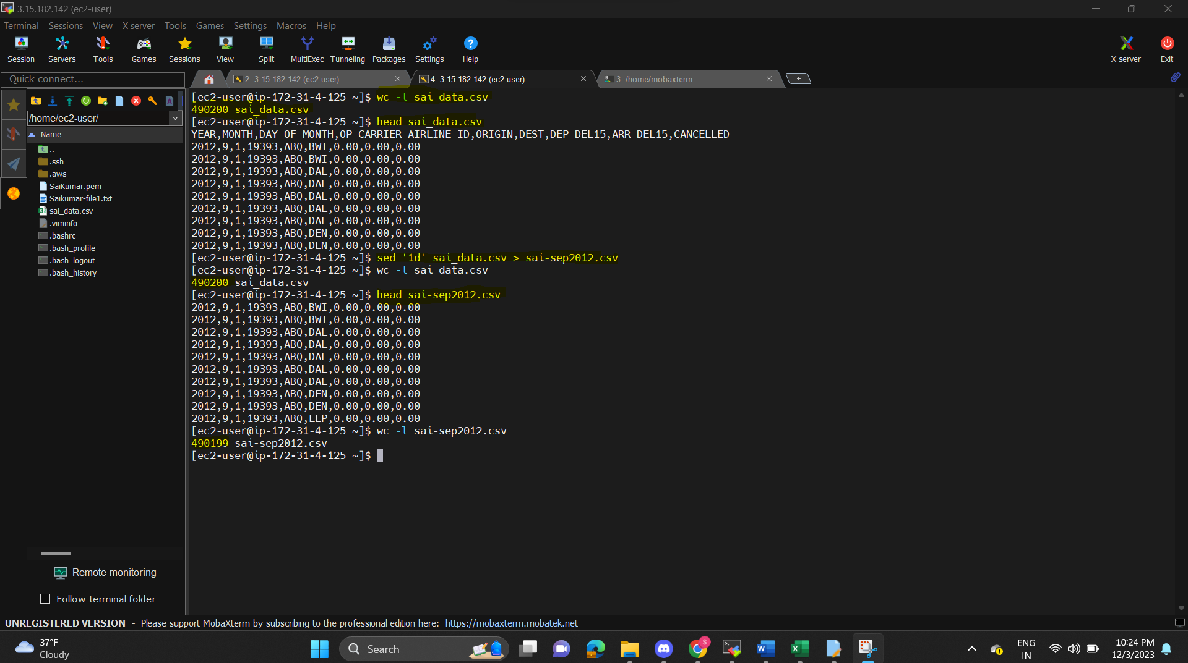

Uploading the Sai-sep2012.csv file to s3

Database connection

Table created and imported data

1. Query on the database
2. Query for total count

1. United code 19977

1. Cancelled united airlines

1. Total number of flights for United Airlines from Chicago O’Hare to Los Angeles:

1. Total number of United Airlines flights delayed leaving O’Hare and going to Los Angeles:

1. Total number of cancellations for American Airlines and United Airlines:

1. Total number of United Airlines flights delayed leaving or arriving at any airport:

5. Data

|  |  |
| --- | --- |
| Your Name | SaiKumar Murarishetti |
| Student ID | L30079224 |
|  |  |
| Month and Year of the data file | Sep -2012 |
| Number of lines in the CSV file | 490199 |
|  |  |
| Answer for Question 4a  (i.e. total number of flights in the dataset) | 490199 |
| Answer for 4b | 42806 |
| Answer for 4c | 257 |
| Answer for 4d | 312 |
| Answer for 4e | 72 |
| Answer for 4f | 1304 |
| Answer for 4g | 9324 |
|  |  |

6. Stop the instance of RDS

Deleting the instance of RDS

Bucket deleted

